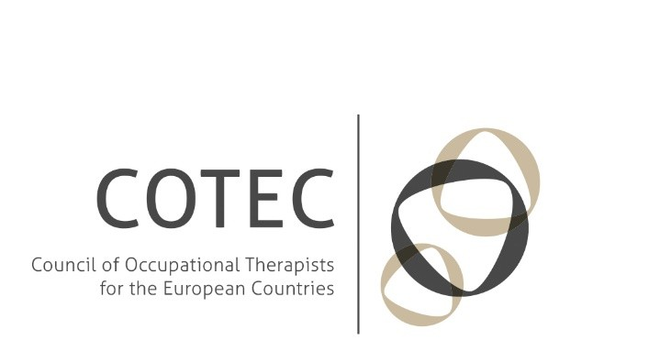

To the Minister of Education, Research & Religious Affairs, Prof. Gavroglou To Athens University of Applied Sciences, Prof. Bratakos

To the President of Piraeus University of Applied Sciences, Prof. Vryzidis To the President of Crete University of Applied Sciences, Prof. Kapetanakis

Cc: The Hellenic Association of Ergotherapists

15 July, 2017

**Restructuring of the Highest Level Education Schools in Greece**

The Council of Occupational Therapists for the European Countries (COTEC) has recently been informed that the Hellenic Ministry of Education has decided on merging the School of Occupational Therapy and the School of Physical Therapy.

COTEC is the European organisation for occupational therapy which has 30 national associations for occupational therapy in 30 countries as members and represents more than 150,000 occupational therapists across Europe. COTEC is a regional group of the World Federation of Occupational Therapists (WFOT). In Europe occupational therapy is an autonomous regulated health profession (within the terms of the General Directive (2005/36/EC) and recognised as academic profession/discipline by the different ministries of education and health in 28 of the countries of the Member Associations of COTEC.

Occupational Therapy educational programs are worldwide approved by the WFOT Minimum Standards every fifth year. In Europe there are more than 200 Occupational Therapy educational programs approved by WFOT, one of them being the School of Occupational Therapy in Athens, which ensures a good quality of education.

The School of Occupational Therapy and the School of Physiotherapy represent different fields of study and practice as Occupational Therapists and Physiotherapists have different professional competences. Even more important is the fact that the School of Occupational Therapy of the



Technological Educational Institute of Athens is the only public/state Occupational Therapy School in both Greece and Cyprus, and should guarantee an excellent occupational therapy education.

Although COTEC Executive Committee understands the need of economic measures in this time of austerity, merging of schools do not always have a saving aspect. Especially as a merge should be prepared in a way that ensures the independence of the professions and that both professions are treated equally. If this is not guaranteed COTEC Executive Committee strongly believes that a merge will inevitably lead to reduced quality of the professional core competences and of the services that occupational therapists provide in the community for people of all ages which have a limitation in their occupational performance and participation. We stress that in times of austerity occupational therapists can contribute to society by supporting people to be less dependent of care and as such save money.

COTEC Executive Committee strongly requests that the Ministry of National Education and Religious Affairs rethink the decision of merging the School of Occupational Therapy and the School of Physical Therapy and if the schools cannot be equal partners with equal rights and if the program and the quality of occupational therapy education cannot be guaranteed withdraws the decision.

Sincerely,



COTEC president