Yv# $%& d()*+d $%ç A.E. $%ç /012+013 $%ç 4%µ150d$*dç 6d$70*&dç 8d5799d01v1:913

!TE$H &IT!E(T)*! +*P(AP*!

!IE$NE& &YNE!(I)
! pú$! c&r ()*µ+c&:
Au# $% &'()*% *$% +táş/*% 01t $%( u2#*3%4% $5/ E)&c-x)/c01 6121*0)/7 22 '89 :/2t107 24 ;5/3<5/ 2022
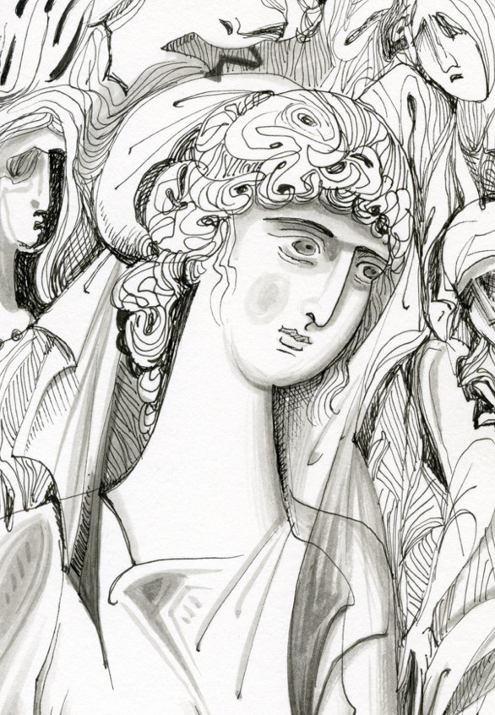

E99%&(5# ;7<1)7(d5# /d&7v(<$=µ(1 – Tpu$%&ó( )%&*+a(

=;>?@>A AB@>=C;D
! pú$! c&r ()*µ+c&:
Au# $% &'()*% *$% +táş/*% 01t $%( u2#*3%4% $5/ E)&c-x)/c01

8>ET@ AB>8EC>DE8 6EFCAFE8

OPT$N&T()* +M(TPOM*

A.+/% 0a.a12/% & 034p56( 0a.a12/%( A1&41%( A1%7%&2/%(
8ap+a 03a11a/2/% 9a&*p+1a 06u.3:.µ6u A;a12<36( =a5/ó&%(
8ap3211a 9a&%>óp% É..% @6u.a/2/% TA+1a )&*$a1321

EMI$T&M()I*($ +ME+,+)($: )&:>a16( 9a/.aµ21%(

TP$WW$T+($

B:<$631a Ca&A%D2/%
E.*u;:p36( @*ppF&G(
)6>+a H6u<&:p%

T

83&1v$(5# /0#)0dµµd

M.µ/01 21 (234523
19:30 )&:5% I3&<:1&A6( 96p12p6(
E5/a+13a &%( :/;*<%( «T<J a52$%( &6 /aµ+13» &6u 034p56u 9ópD%.
K*a&p3/ó a1a.ó536 a$ó &6 K:a&p6 &%( )%&*+a( µ* a$6<$2<µa&a a$ó &61 Ep#$%&p'$(
/a3 µ6u<3/G *$:1Du<% a$ó &6 034p56 8a<&6p2/%.

M67689:3; 22 (234523
11:00 )&:5% I3&<:1&A6( 96p12p6(
«L D3/ó( µ6u EpF&ó/p3&6(»: )ú1&6µ*( µap&up+*( )&*3a/41N a>%56ú1&a3 &% O3Fµa&3/G, 7uP6.653/G, /a..3&*P13/G G *$3<&%µ613/G <P:<% &6u( µ* &6 $6+%µa.

17:30 E..%13/ó 8*<65*3a/ó @a1*$3<&Gµ36 - Tpu$%&ó( )%&*+a(
L 03211%( I2pDa( (Qupap653211%() a$a55:..*3 D3/2 &6u $63Gµa&a /a3 a$6<$2<µa&a a$ó &61 Ep#$%&p'$(.

18:00-21:00 )RSEBTUL: 1! )u1*Dp+a

<=>>602 23 (234523
10:00-14:00 )RSEBTUL: 2! /a3 3! )u1*Dp+a

21:00 Hp6úp36 9aA2pµa
86u<3/G $ap2<&a<% Ep#$%&p'$() a$ó &6u( CaV1%D*( /a3 &%1 6µ2Da P6p6ú a/p6Oa&3/41
*' %µ+) &'rsí$/'.

)37t69; 23 (234523
10:00-14:30 )RSEBTUL: 4! /a3 5! )u1*Dp+a

17:00 W*125%<% &F1 <u1:DpF1 (E&32, :$au.% De Mezzo)

22:00 Iap/apó.a <&6 .3µ213 &%( )%&*+a( µ* &6 <u5/pó&%µa 01í$/ *%p2/.

o (t s/0123s4 567 $78s9/367 0386851t 256 :µ;t<=15/6 567 Tµ>µ1564 Eut25@µA8
Bt15/6;>4 – Bt1t56C60314. ECC@8tDó Ms260st1Dó M18sut25>µt6 – T/7u@5ó4 $@5s314.
o $5674 FA/674 5G8 sD9@CA2sG8 <1 s;1/µ6256ú8 51 70st686µtDá u/G5óD6CC1 u67 <1
t2Fú678 5ó5s.

Yv# $%& d()*+d $%ç A.E. $%ç /012+013 $%ç 4%µ150d$*dç 6d$70*&dç 8d5799d01v1:913

8>ET@ AB>8EC>DE8 6EFCAFE8

=;>?@>A AB@>=C;D
! pú$! c&r ()*µ+c&:

Au# $% &'()*% *$% +táş/*% 01t $%( u2#*3%4% $5/ E)&c-x)/c01

T

/0#)0dµµd

@apa</*uG 22 ULRQULR 2022

+N$P)T*P($ <@N+AP($
17:30 L 03211%( I2pDa( (Qupap653211%() a$a55:..*3 D3/2 &6u $63Gµa&a /a3 a$6<$2-
<µa&a a$ó &61 Ep#$%&p'$(
18:00 9a.F<óp3<µa )&:5%( - 034p56( 0a.a12/%( @p6<>F1G<*3(

1! <@N+AP($
@p6*Dp*+6: )6>+a H6u<&:p%
1. 18:30 )&:>a16( 9a/.aµ21%(, X ">ú<% &F1 $paµ2&F" <&61 Ep#$%&p'$(
19:00 B32.*3µµa.

2. 19:30 Ia<+.%( @a$aDó$6u.6(, @ó.*µ6( /a3 *3pG1% <&61 Ep#$%&p'$(. É1a(
/4D3/a( &3µG( $6u P2;%/*
3. 20:00 UF211%( 936up&<2/%(, L a&:.*3F&6( D32.656( &%( E..%13/G( 3<&6p+a(.
Wa1aD3aO2A61&a( &61 «EpF&ó/p3&6» &6u 034p56u )*>:p%
20:30 )uAG&%<%
21:00 QGY% <u1*Dp+a(.

T

)2OOa&6 23 ULRQULR 2022

ETZTL9TUTL), &6 /*+µ*16 /a3 63 /a&aO6.:( &6u

2! <@N+AP($
@p6*Dp*+6: Cristiano Luciani
1. 10:00 Ulrich Moennig, T6 .656&*P13/ó *+D6( &6u Ep#$%&p'$(3 /a3 % ;*Fp+a &F1
*3D41
2. 10:20 T+1a Q*1&2p%, )&%( "*pF&32( &% <&p2&a": <u1:P*3*(, µ*&a$.2<*3( /a3 a1a<%µa&6D6&G<*3( &%( µu;3<&6p%µa&3/G( $ap2D6<%( <&61 Ep#$%&p'$(
3. 10:40 @a1a534&a Ia<3.2/%, Ep#$%&p'$()-4µ56p'(): A$ó &6 $pó&u$6 <ú1;*<%(
<&%1 $pF&ó&u$% D%µ36up5+a
4. 11:00 Épp3/a A1Dp6u.2/%, A$*3/61+<*3( &%( >3.32( <&61 Ep#$%&p'$( /a3 <&3( $*p+
:pF&6( 3&a.3/:( $pa5µa&*+*( &6u 166u a341a
11:20 )uAG&%<%
11:50 B32.*3µµa - Tpa56úD3a /a3 P6pó( a$ó &6 86u<3/ó 0uµ12<36 Qa<3;+6u.

3! <@N+AP($
@p6*Dp*+6: Eup3$+D%( 0apa1&6úD%(
5. 12:20 E3pG1% @a$aD2/%, Della magia d’amore: % $*p+ :pF&6( $pa5µa&*+a &6u
Guido Casoni /a3 % $6+%<% &F1 96p12pF1
6. 12:40 8ap+a @2<<6u, A1aA%&41&a( &6 $63µ*13/ó a$6&ú$Fµa &6u Ep#$%&p'$(3
7. 13:00 8ap+1a T6D6<;:16u( 8$a.2>a, Ta <PGµa&a &6u 6YúµFp6u /a3 &6u
$ap2D6Y6u <&61 Ep#$%&p'$( &6u 96p12p6u
8. 13:20 B%µG&p%( @apaD6u.2/%(, A$ó &6 *//.%<3a<&3/ó /Gpu5µa <&%1 $63%&3/G &:P1%: 9úp3..6( Q6ú/ap3( /a3 I3&<:1&A6( 96p12p6(
13:40 )uAG&%<%
14:00 QGY% <u1*Dp+a(.

T

21:00 Hp6úp36 9aA2pµa
86u<3/G $ap2<&a<% Ep#$%&p'$() a$ó &6u( CaV1%D*( /a3 &%1 6µ2Da P6p6ú a/p6Oa&3/41
*' %µ+) &'rsí$/'.

9up3a/G 24 ULRQULR 2022

ETZTL9TUTL), % D32Pu<% /a3 % $pó<.%7G &6u

4! <@N+AP($
@p6*Dp*+6: Ulrich Moennig
1. 10:00 Tudor Dinu, H u$6D6PG &6u Ep#$%&p'$(3 <&61 p6uµa1ó>F16 P4p6 &6 186
/a3 &6 $p4&6 µ3<ó &6u 196u a341a
2. 10:20 S+/6( 8aup:.6(, L3 µ*&aµ6p>4<*3( &6u µu;3<&6p%µa&3/6ú *+D6u( a$ó &61 EpF&ó/p3&6 <&6 7'8(96(3 :;psp</ &6u S3/ó.a6u 8aup6/6pD2&6u
3. 10:40 03211%( W6úp3a(, «Au&G % >.ó5a &%( /apD32(» a$ó &61 Ep#$%&p'$( <&a
>a1ap34&3/a <&3P6up5Gµa&a /a3 &pa56úD3a
4. 11:00 Eup3$+D%( 0apa1&6úD%(, L $63%&G( 034p56( )*>:p%( /a3 6 Ep#$%&p'$()
11:20 )uAG&%<%
11:50 B32.*3µµa - &pa56úD3 a$ó &% 8ap+a 96u1*.2/%.

5! <@N+AP($
@p6*Dp*+6: Tudor Dinu
1. 12:20 9F1<&a1&+16( 8$óµ$a(, X $6.uD32<&a&% $p66$&3/G &%( <u..653/G(
µ*&2>pa<%( &6u Ep#$%&p'$(3 <&a 5a..3/2. 8*&a>pa<&3/:( µ1Gµ*( /a3 $6.3&3-
<µ3/:( $p6O6.:(
2. 12:40 Cristiano Luciani, O Ep#$%&p'$(): µ*&2>pa<% <&a 3&a.3/2 /a3 A%&Gµa&a
$63%&3/G(
3. 13:00 A;a12<36( =a5/ó&%(, Aµ>3-;:a&p6, µ*&a$6.+&*u<%, 1*6*..%13/ó ;:a&p6: L
Ep#$%&p'$() &6u )$úp6u Eua55*.2&6u <&6 /6µO3/ó <%µ*+6
4. 13:20 )&aµa&+a Qa6uµ&AG & Ulrich Moennig, ='58> µ/$';: 6 </%16;:&%( *pµ%- 1*ú61&a(, 6 *pµ%1*u&G( </%16;*&41&a(. L 83P2.%( @3*pG( /a3 6 Ep#$%&p'$()
13:40 )uAG&%<%
14:05 B32.*3µµa - a1a5*11%<3a/G µ6u<3/G a$ó &6 034p56 8a<&6p2/%.

)$T$B*)T*P($ <@N+AP($
14:15 )uµ$*p2<µa&a - EuPap3<&+*( QXWX &6u )RSEBTULR.

T

17:00 W*125%<% &F1 <u1:DpF1 (E&32, :$au.% De Mezzo)
22:00 Iap/apó.a <&6 .3µ213 &%( )%&*+a( µ* &6 <u5/pó&%µa 01í$/ *%p2/.

